Infoporn: Proof That the FDA Isn’t Protecting Americans’ Health
- BY NICK STOCKTON 02.12.15 | 9:00 PM

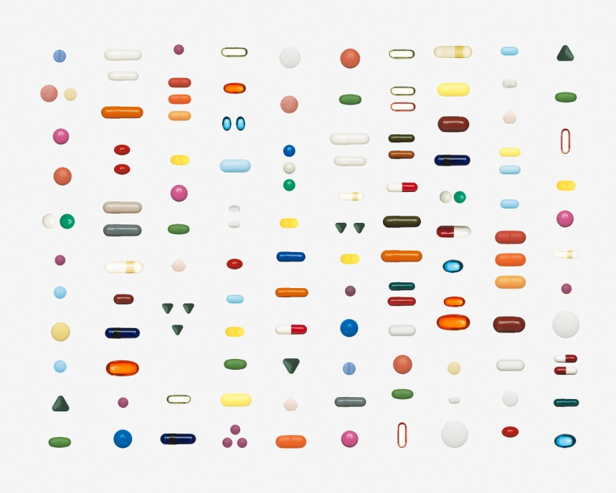
Making drugs is tricky business. It’s also expensive, so it’s no shocker that labs take scientific shortcuts when trying to get a treatment to market—where it can start earning back the millions of dollars spent in development. Whenever the FDA catches falsified data or unreported side effects, it issues a warning letter to document the bad research. That’s good. But a new study shows the FDA also goes to extreme lengths—from bureaucratic obfuscation to outright redactions—to hide any links between that negligence and any particular drug. That makes it impossible to tell if these letters are doing anything to protect consumers.
Information ain’t always pretty. The busted-looking chart below is a list of clinical trials—the crucial studies that ensure drugs are safe and effective—containing flawed research.
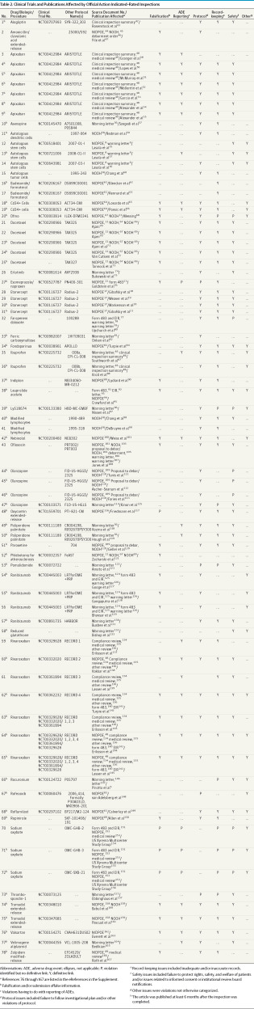
This information came from the FDA, but not directly. Instead, a team of investigative journalists had to scrounge to find the missing links between bad research and the drugs it was performed on. “I look at warning letters from the FDA, and see these awful things happening in clinical trials that are rarely reported,” says Charles Seife, a journalist and professor at NYU who led the research. The 57 clinical trials listed here (there are 78 records because some clinical trials contain multiple lines of bad research) are only a fraction of what he found. In all, hepublished evidence of approximately 600 clinical trials with significant scientific and ethical lapses—lapses the FDA did their best to hide.
Want some examples? How about the study on a treatment for leg blood clots that claimed the legs were getting a lot better, when one of the patients actually needed his foot amputated? Or falsified research in eight of the 16 research sites investigating a single blood clotting treatment? Or the researcher who was disbarred and sent to prison for overdosing a chemotherapy patient? All of these were reported in warning letters, but missing from the peer-reviewed research.
To find the connections between those lapses and the drug trials they affected, Seife had to piece together a puzzle of FDA paperwork. (He’s a bit of a professional muckraker, evenanalyzing Jonah Lehrer’s journalistic misdeeds at WIRED.) Over the course of a semester, he and his investigative reporting class issued Freedom of Information Act (FOIA) requests and combed the FDA’s website to find warning letters. (Disclosure: I am a former student of Seife’s, but did not contribute in any way to this investigation.) But the FDA removes any information in those letters that could be tied back to the drug being studied—by omitting or redacting the names of drugs, the names of clinical trials, and any information describing how the misconduct affected the outcome of the trial.
That meant Seife’s team had to cross-reference clues from the letters with other reports about clinical trial warnings and the occasional notification contained in peer review. But even with a small army of grad students helping drum up evidence, Seife was only able to close the loop on 57 of the 600 warning letters. Whether or not the fruits of this faulty research are sitting on pharmaceutical shelves is a mystery.
These results are disconcerting, especially in the larger context of research infractions. The number of scientific retractions—closely monitored by sites like Retraction Watch—has risen sharply in recent years, and the fraudulent research behind those retractions isn’t limited to clinical trials. Bad science is everywhere. It’s not clear whether there’s actually more bad science than there used to be, or whether we’re just better at finding it in the Internet age, but in either case it puts us at risk.
In the case of clinical trials, all this intentional fogginess makes these reports useless to who they should matter to the most: the drug-using public. “Unless you’re lucky or have the time to go through the FDA documents and crack the redactions,” says Seife, “you can’t know if the drugs you are taking are based on faulty research.”
Clinical trials are years-long, rigorous scientific tests that are supposed to ensure a drug does what it says it’s going to do, without debilitating side effects. They should be held to the highest standards possible—your doctor weighs that data against your patient history to make sure you get the proper treatment. “They’ll be digging through the journals to find out if the drug works,” says Seife. “And if those studies don’t show that there is a problem, then your doctor is not going to find out.”
By removing the link between warning letters and the drug trials they impact, the FDA has hamstrung your doctor’s ability to make an informed decision about your health. Talk about bad medicine.

